**WEALTH MANAGEMENT OPERATIONS**

Wealth management operations in U.S. banking encompass a wide range of financial services aimed at helping clients grow, manage, and protect their wealth.

• Investment Management

• Financial Planning

• Trust and Fiduciary Services

• Private Banking

• Insurance Services

• Specialized Advisory Services

• Client Education and Communication

As of 2020, the industry's total AUM exceeded $30 trillion, with continued growth expected in the coming years​

|  |  |
| --- | --- |
| Total Assets Under Management (AUM) | Over $30 trillion (2020) |
| Annual Growth Rate of $10M+ Relationships (RIAs, 2016-2022) | 13% |
| Annual Growth Rate of $10M+ Relationships (Warehouses, 2016-2022) | 8% |
| Projected AUM Managed by Digital Platforms (2024) | $1.26 trillion |
| Expected AUM Managed by Robo-Advisors (2022) | $1.4 trillion |
| Number of Registered Investment Advisors (RIAs) | More than 16,000 |
| Average Client Attrition Rate | 8% |
| Portion of Millennial Investors Using Robo-Advisors | 45% |
| Proportion of Investment Portfolios Held in Equities by Wealthy Investors | 32.2% |
| New Clients Gained During the Pandemic | Over 5 million |
| Projected Wealth Transfer from Baby Boomers to Millennials (Next 25 Years) | $41 trillion |
| Portion of Net New Money from Female Clients (2020) | 65% |
| Portion of Wealth Management Firms Using Data Analysis for Growth | |  | | --- | | 45% |  |  | | --- | |  | |
| Percentage of Clients Willing to Pay More for Personalized Advice | 20% |
| Average Age of Financial Advisors in the U.S. | 55 years |

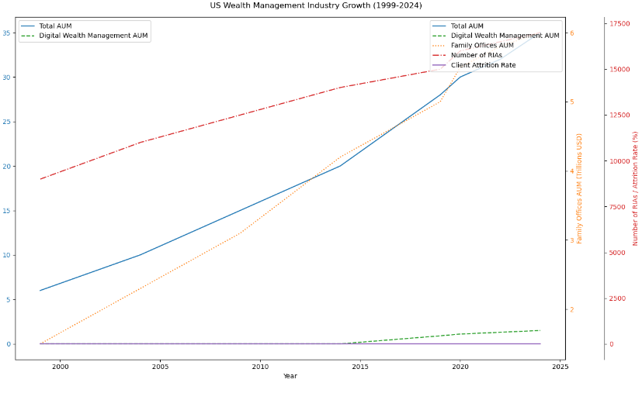

**TREASURY MANAGEMENT SERVICES**

Treasury management operations of US banks encompass a variety of services designed to optimize a company’s liquidity, manage cash flow, and mitigate financial risks.

1. **Cash Management**: Efficient handling of a company’s cash inflows and outflows to ensure adequate liquidity. This involves techniques like cash concentration, zero balance accounts, and notional pooling.
2. **Payments and Receivables**: Streamlined processes for managing incoming and outgoing payments, including automated clearing house (ACH) transactions, wire transfers, and electronic funds transfers (EFT).
3. **Liquidity Management**: Strategies to optimize the use of a company’s liquid assets. This includes short-term investments, money market funds, and commercial paper.
4. **Trade and Supply Chain Finance**: Solutions like letters of credit, trade financing, and supply chain financing to support international trade and domestic supplier relationships.
5. **Risk Management**: Tools and strategies to hedge against financial risks such as foreign exchange risk, interest rate risk, and commodity price risk. This may involve the use of derivatives like forwards, futures, options, and swaps.
6. **Account Reconciliation**: Services that help companies reconcile their bank statements with their internal accounting records to ensure accuracy and identify discrepancies.
7. **Fraud Protection**: Measures to protect against fraudulent activities, including positive pay, ACH debit blocks, and dual authorization for transactions.
8. **Information Reporting**: Providing timely and accurate financial information through online banking platforms, dashboards, and custom reports to aid in decision-making.

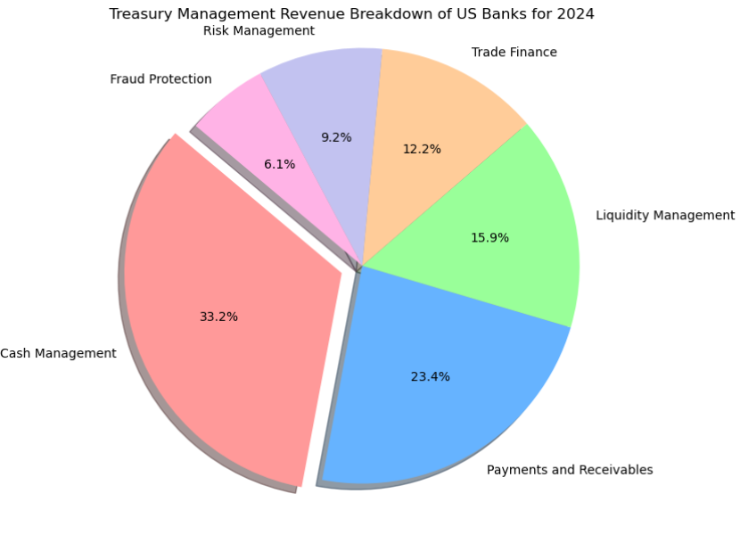

**RISK MANAGEMENT OPERATIONS**

Risk management in US banking operations involves systematically identifying, assessing, and mitigating potential risks to ensure financial stability and compliance. The primary types of risks managed include:

1. **Credit Risk**: The possibility of loss due to a borrower's failure to repay a loan. Banks mitigate this through rigorous credit assessments and diversification of loan portfolios.
2. **Market Risk**: The risk of losses due to fluctuations in market prices, including interest rates and foreign exchange rates. Banks use hedging strategies and value-at-risk models to manage this risk.
3. **Operational Risk**: Risks arising from inadequate or failed internal processes, people, and systems, such as fraud or cybersecurity threats. Effective internal controls and regular audits are key mitigation strategies.
4. **Liquidity Risk**: The risk of not being able to meet short-term financial obligations. Banks maintain sufficient liquid assets and contingency funding plans to address this.

Key regulatory frameworks include the Dodd-Frank Act and Basel III, which set standards for risk management practices. Tools such as stress testing, scenario analysis, and risk-adjusted return on capital (RAROC) are commonly used to measure and manage risks​.

According to 2023 update:

|  |  |  |  |
| --- | --- | --- | --- |
| Risk Type | Average Loss (%) | Mitigation Cost (%) | Compliance Rate (%) |
| Credit Risk | 0.8 | 1.2 | 99 |
| Market Risk | 0.5 | 0.9 | 98 |
| Operational Risk | 0.7 | 1.1 | 97 |
| Liquidity Risk | 0.3 | 0.5 | 99 |
| Compliance Risk | 0.2 | 0.4 | 99 |

